37.66: a) b) In Sebulbas frame, the relative speed of the tachyons and the ship is 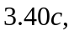 and so the time 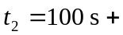
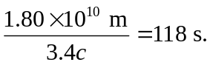 At Sebulba measures that Watto is a distance from him of c) From Eq. (37.23), with with the plus sign indicating a direction in the same direction as Watto’s motion (that is, away from Sebulba). d) As the result of part (c) suggests, Sebulba would see the tachyons moving toward Watto and hence is the time they would have left Sebulba in order to reach Watto at the distance found in part
(b), or 118 s 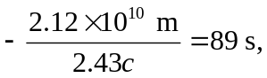and so Sebulba receives Watto’s message before even sending it! Tachyons seem to violate causality.

